## CMS-Converter Tool

Place The cms-converter tool in the server.

The cms-conveter-tool contains the lib,log folders ,the script(cms-tool.sh)

and the properties file.

Example:

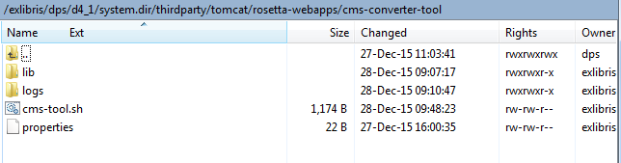

- Provide a list of updated CMS-records in text file.

Example:

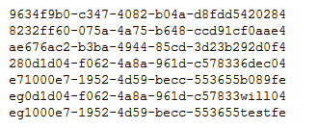

- write the location of the CMS-records files (the input files) in the properties file (The default location for the input file is $op_dir/CMS_Sync/Input)

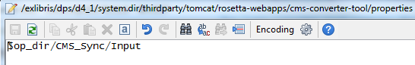

-Place CMS-records files in the location that you configured in the properties file.

Browse to cms-converter-tool directory

- run the script: sh cms-tool.sh

After you running the script you can see the script logs and see if there are errors/warnings.

- Check that Files that were processed moved to ../processed.

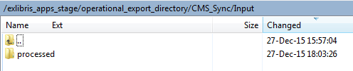

The tool will create xml files in the location Rosetta CMS update job uses for further processing.



- Run the 'Metadata Loader' job from Home > Advanced Configuration > Manage Scheduled Jobs.